Rafting Site - Planning Document

1. The image file you selected for the site logo.

Answer: https://byui-cse.github.io/wdd130-ww-course/resources/images/logos/z-rapids-trees.jpg

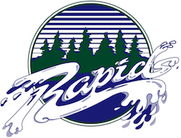

2. Write out the four (4) color labels (listed below) with the color codes you selected:

* Primary-color: #284b63
* Secondary-color: #edede9
* Accent1-color: #ffffff
* Accent2-color: #000000

1. Write out the two (2) font labels (listed below) and the names of the fonts you selected:

* Heading-font: Montserrat
* Text-font: Lato

1. Provide the URL link to your color palette that you designed in coolors.co  
   Here is an example URL link:

<https://coolors.co/palette/284b63-edede9-ffffff-000000>